Anas Aly
CSCI 431
Professor Subhankar Banerjee

Assignment 1
- What is the problem you are solving above?
My goal is to predict whether a Titanic passenger survived based on their characteristics: social class, age, fare, family size, sex, place of embarkation, and title (Mr., Mrs., etc.) using historical data from the Titanic dataset.
- How will you categorise this problem? (Supervised/unsupervised; classification/regression; online/batch learning)
This is a supervised classification problem solved using a Random Forest Classifier. It is supervised because we have labeled training data showing who survived. It is classification because the output is binary — survived (1) or did not survive (0). I used batch learning since the dataset is static and small enough to train on all at once. A more sophisticated real-time system, such as a fraud detection system, would instead use online learning to continuously update as new data arrives.
- A summary of all the analysis done and the results
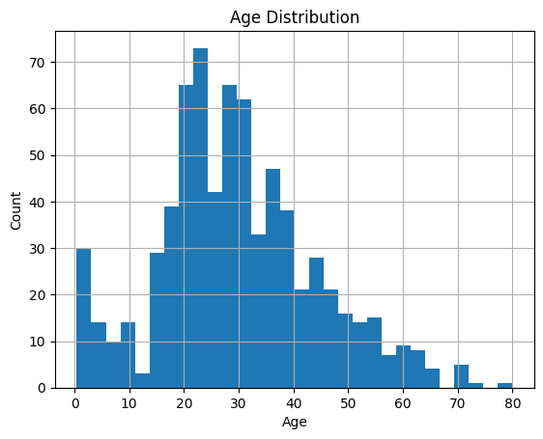

- Age Distribution: a histogram revealed that most passengers were between 20-30 years old, with fewer children and elderly passengers.
- Standard Deviation of Age: the standard deviation was 14.53 years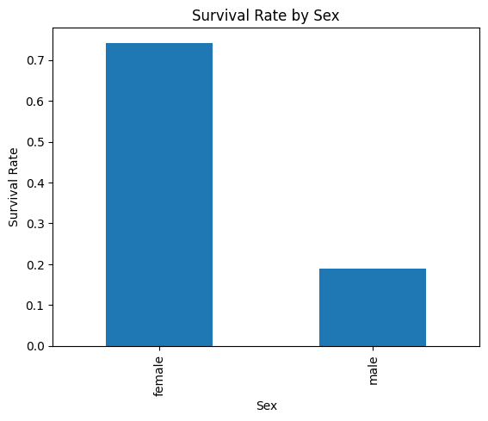
- Survival Rate by Sex: Female passengers are more likely to survive compared to male passengers, indicating sex was a strong predictor of survival.
- Model Results: the Random Forest Classifier achieved a mean cross-validation accuracy of approximately 80.47%

